**Multi-temporal Land Use Land Cover (LULC) change Analysis using ERDAS Imagine Software**

**by**

**Shuvam Sanyal(PRN-19070243015) & Pritha Roy(PRN-19070243020)**

**Introduction**

Land is defined as a place on which all human activity is being conducted. Use of land resources by the people gives rise to ―land use, which varies with the purposes it serves, whether they be food production, provision of shelter, recreation, extraction and processing of materials, and the bio-physical characteristics of land itself. Hence, land use is being shaped under the influence of two broad sets of forces – human needs and environmental features and processes. The terms land use and land cover are not synonymous and the literature draws attention to their use and land cover change. Land cover is the biophysical state of the earth’s surface differences so that they are used properly in studies of land and immediate subsurface. It describes the physical state of the land surface; e.g., cropland, mountains or forests. Land cover deals with the quantity and type of surface vegetation, water, and earth materials i.e. man-made constructions (buildings etc), the type of material used in housing structure. The term land cover originally referred to the type of vegetation that covered the land surface, but has broadened subsequently to include other aspects of the physical environment also, such as soils, biodiversity and surfaces and groundwater. In the disaster-prone areas of landslides, the destruction of forests and the vegetative cover that binds the top soil at an increasing pace and the conversion of forest land into agricultural and horticultural holdings brings changes in land use and land cover.

**Review of Literature**

The understanding of land-use/land cover change has moved from simplicity to realism and complexity over the last decades. In the beginning, the studies were concerned mostly with the physical aspect of the change, but later, in the research agenda on global environmental change. Scientists realized that land surface processes influence climate because of the land use/cover change. In mid1970s, it was recognized that land cover change modifies surface albedo and thus surface atmosphere energy exchanges, which have an impact on regional climate. Much broader range of impacts of land-use/cover change on ecosystem, goods and services were further identified. Of primary concern are impacts on biotic diversity worldwide, soil degradation and the ability of biological systems to support human needs.

In order to use land optimally, it is necessary to have the information on existing land use land cover. It is also important to have capability of monitoring the dynamics of land use resulting out of both changing demands of increasing population and forces of nature acting to shape the landscape. Land is in a continuous state of transformation as a result of various natural and man-made processes. The study of spatio-temporal patterns of intra and inter urban form and understanding of the evolution of urban systems are still primary objectives in urban research. Land use/land cover change detection process of identifies the differences in the state of an object or phenomenon by observing it at different times. Change detection is an important process in monitoring and managing natural resources and urban development because it provides quantitative analysis of the spatial distribution of the population of interest. Macleod and Congation list four aspects of change detection which are important when monitoring natural resources. They include; firstly, detecting the changes that have occurred; secondly, identifying the nature of the change; thirdly, measuring the area extent of the change and lastly, assessing the spatial pattern of the change. The basis of using remote sensing data for change detection is that changes in land cover result in changes in radiance values which can be remotely sensed. Techniques to perform change detection with satellite imagery have become numerous as a result of increasing versatility in manipulating digital data and increasing computer power. Conventional ground methods of land use mapping are labour intensive, time consuming and are done infrequently. These maps soon become outdated with the passage of time in a rapid changing environment. In recent years, satellite remote sensing techniques have been developed, which have proved to be of immense value for preparing accurate land use/land cover maps and monitoring changes at regular intervals of time. Despite spatial and spectral heterogeneity challenges of urban environments, remote sensing seems to be a suitable source of reliable information about the multiple facets of urban environment. So, the analysis of dramatic changes of land use/land cover at global, continental and local levels and further to explore the extent of future changes, the current geospatial information on patterns and trends in land use/land cover are playing an important role.

Remotely sensed imageries provide an efficient means of obtaining information on temporal trends and spatial distribution of urban areas needed for understanding, modelling and projecting land changes. In case of inaccessible regions, this technique is perhaps the only method of obtaining the required data on a cost and time effective basis . Satellite imagery is able to provide more frequent data collection on a regular basis unlike aerial photographs. Although aerial photographs may provide more geometrically accurate maps but is limited in respect to its extent of coverage and expenses.

A remote sensing device records response which is based on many characteristics of the land surface, including natural and artificial cover. An interpreter uses the element of tone, texture, pattern, shape, size, shadow, site and association to derive information about land cover. The generation of remotely sensed data/images by various types of sensor flown aboard different platforms at varying heights above the terrain and at different times of the day and the year does not lead to a simple classification system. It is often believed that no single classification could be used with all types of imagery and all scales.

Historically, humans have been modifying land to obtain the essentials for their survival, but the rate of exploitation was not the same as it is today. Recent rapid rate of exploitation has brought unprecedented changes in ecosystems and environmental processes at local, regional and global scales. Presently, land use/land cover changes encompass the environmental concerns of human population including climate change, biodiversity depletion and pollution of water, soil and air. Today, the monitoring and mediating the adverse consequences of land use/land cover change while sustaining the production of essential resources has become a major priority of researchers and policy makers around the world.Unsustainable human activities are becoming key environmental concern as they deteriorate the quality of water in the. The relationship between land use and water quality helps in identifying threats to water quality rivers and built an understanding of about ‘access’ to sanitation is crucial for human survival.

**Study Area**

Our study area is the study area of three satellite images from 1991, 2001,2011 provided.

**Methodology and Classified Images**

At first, we have taken one multi temporal satellite image one at a time and then opened it with ERDAS Imagine software. Then we start applying supervised classification on it using signature editor. Then we run the supervised classification on these classes of the images and got the supervised classification output images for each of the years. first stage of the supervised classification process is that we collected reference training sites for each land cover type in order to generate training signatures. Then we opened a viewer with the image displayed in false colour composite mode. Then we opened the Signature Editor tool from the Classification menu. Using the polygon tool from the AOI tools (Area of Interest), we defined a polygon which are representatives of one of the four regions on the images namely: -Urban Land, Barren Land, Vegetation& Forest and Water. If you wish you can define a second area from a water body. You should then select both AOI’s by holding down the shift key and clicking on the first polygon and click on the Group icon from the toolbox. To create a signature from these AOI’s, we selected selected the Edit, add option from the Signature Editor window, changed the colour of the class and the class name to one of those four respective regions in images. In this way, we have imported 26 classes in the signature editor for each of the four regions on the images namely: -Urban Land, Barren Land, Vegetation and Water. Then we merged each of these 26 signature points for each class and created single separate classes for each of the four above mentioned regions.

***Supervised Image Classification for December 1991 Satellite Image***

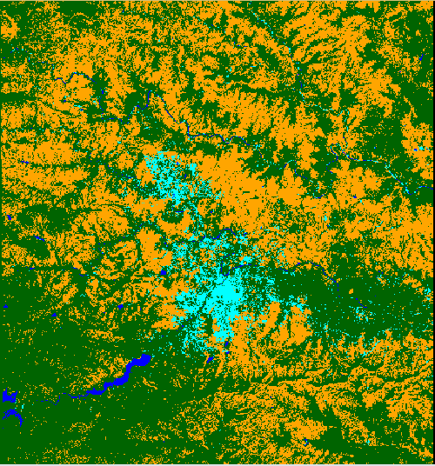

**Supervised Image Classification for January 2001 Satellite Image**

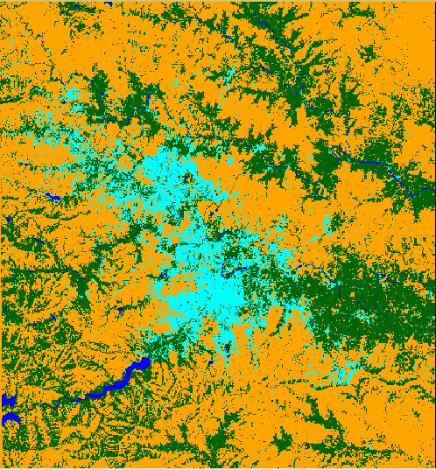

**Supervised Image Classification for January 2011 Satellite Image**

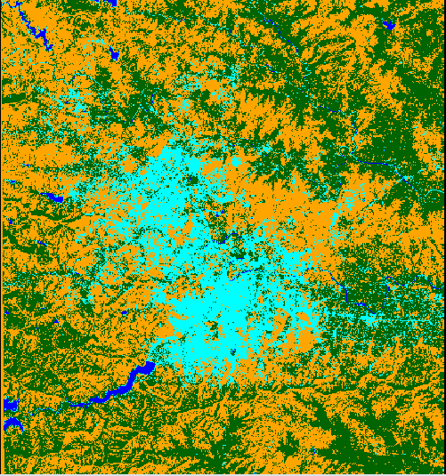

In all the above classified images, we have four classes denoted by four colours. Urban region is defined by cyan; the water region is defined by blue; the vegetation and forest areas are defined by green and the barren land is marked with brownish orange. Now we have calculated the areas associated with each of the region for different years (1991,2001,2011) in three images to analyse the change in area and land cover in those images over the years. At the end, we have done the accuracy assessment of each of the classified images to check how many classes have correctly classified and what are the percentages of accuracy and kappa statistics, we have achieved while doing the image classifications. Based on the accuracy assessment, finally we have concluded with our outcomes regarding the land cover changes over the years in these three images.

**Rationale for methodology**

**Supervised classification** is based on the idea that a user can select sample pixels in an image that are representative of specific classes and then direct the image processing software to use these training sites as references for the classification of all other pixels in the image. Training sites (also known as testing sets or input classes) are selected based on the knowledge of the user. The user also sets the bounds for how similar other pixels must be to group them together. These bounds are often set based on the spectral characteristics of the training area, plus or minus a certain increment (often based on “brightness” or strength of reflection in specific spectral bands). The user also designates the number of classes that the image is classified into. Many analysts use a combination of supervised and unsupervised classification processes to develop final output analysis and classified maps.

Training sites are areas that are known to be representative of a particular land cover type. The computer determines the spectral signature of the pixels within each training area, and uses this information to define the statistics, including the mean and variance of each of the classes. Preferably the location of the training sites should be based on field collected data or high-resolution reference imagery. It is important to choose training sites that cover the full range of variability within each class to allow the software to accurately classify the rest of the image. If the training areas are not representative of the range of variability found within a particular land cover type, the classification may be much less accurate. Multiple, small training sites should be selected for each class. The more time and effort spent in collecting and selecting training site the better the classification results

We used the supervised classification method of doing the image classification as n supervised classification the user or image analyst “supervises” the pixel classification process. The user specifies the various pixels values or spectral signatures that should be associated with each class. This is done by selecting representative sample sites of a known cover type called **Training Sites or Areas**. The computer algorithm then uses the spectral signatures from these training areas to classify the whole image. Ideally, the classes should not overlap or should only minimally overlap with other classes. In supervised classification the majority of the effort is done prior to the actual classification process. Once the classification is run the output is a thematic image with classes that are labelled and correspond to information classes or land cover types. Supervised classification can be much more accurate than unsupervised classification.

**Table Depicting change Over the Years**

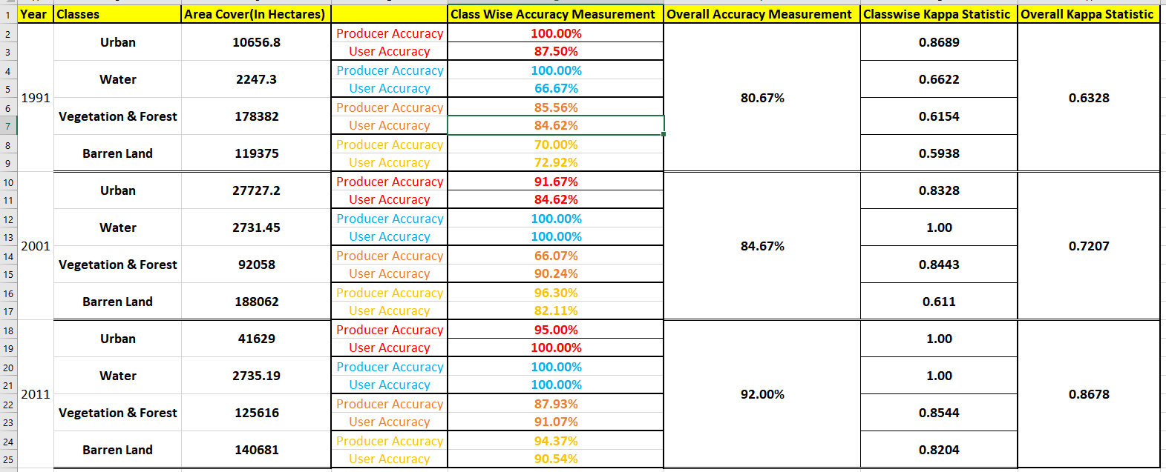

**Results & Findings**

**Accuracy Metrics**

There are many different ways to look at the thematic accuracy of a classification. The error matrix allows you calculate the following accuracy metrics:

* Overall Accuracy and Error
* Errors of omission
* Errors of commission
* User’s accuracy
* Producer’s accuracy
* Accuracy statistics (e.g., Kappa)

## Overall Accuracy

Overall Accuracy is essentially tells us out of all of the reference sites what proportion were mapped correctly. The overall accuracy is usually expressed as a percent, with 100% accuracy being a perfect classification where all reference site were classified correctly. Overall accuracy is the easiest to calculate and understand but ultimately only provides the map user and producer with basic accuracy information.

The diagonal elements represent the areas that were correctly classified. To calculate the overall accuracy you add the number of correctly classified sites and divide it by the total number of reference site.

## Error Types

### **Errors of Omission**

Errors of omission refer to reference sites that were left out (or omitted) from the correct class in the classified map. The real land cover type was left out or omitted from the classified map. Error of omission is sometime also referred to as a Type I error. An error of omission in one category will be counted as an error in commission in another category. Omission errors are calculated by reviewing the reference sites for incorrect classifications. This is done by going down the columns for each class and adding together the incorrect classifications and dividing them by the total number of reference sites for each class. A separate omission error is generally calculated for each class. This will allow us to evaluate the classification accuracy and error for each class

### **Errors of Commission**

Errors of omission are in relation to the classified results. These refer sites that are classified as to reference sites that were left out (or omitted) from the correct class in the classified map. Commission errors are calculated by reviewing the classified sites for incorrect classifications. This is done by going across the rows for each class and adding together the incorrect classifications and dividing them by the total number of classified sites for each class.

## Other Accuracy Metrics

### **Producer’s Accuracy**

Producer's Accuracy is the map accuracy from the point of view of the map maker (the producer). This is how often are real features on the ground correctly shown on the classified map or the probability that a certain land cover of an area on the ground is classified as such. The Producer's Accuracy is complement of the Omission Error, Producer's Accuracy = 100%-Omission Error. It is also the number of reference sites classified accurately divided by the total number of reference sites for that class.

### **User’s Accuracy**

The User's Accuracy is the accuracy from the point of view of a map user, not the map maker. the User's accuracy essentially tells use how often the class on the map will actually be present on the ground. This is referred to as reliability. The User's Accuracy is complement of the Commission Error, User's Accuracy = 100%-Commission Error. The User's Accuracy is calculated by taking the total number of correct classifications for a particular class and dividing it by the row total.

## Kappa Coefficient

The Kappa Coefficient is generated from a statistical test to evaluate the accuracy of a classification. Kappa essentially evaluate how well the classification performed as compared to just randomly assigning values, i.e. did the classification do better than random. The Kappa Coefficient can range from -1 t0 1. A value of 0 indicated that the classification is no better than a random classification. A negative number indicates the classification is significantly worse than random. A value close to 1 indicates that the classification is significantly better than random.

Now, for example for the year 1991: -

**Overall Accuracy**:-

Number of correctly classified site:- 121

Number of correctly reference site:- 150

So **Overall Accuracy** for the 1991 image is =(121/150)*100=80.67%

**Error of Ommision:-**

**Vegetation:-** Incorrectly classified reference sites:- 13 & Total reference class site:-90 So omission error =(13/90)*100=14.44%

**Urban:-** Incorrectly classified reference sites:- 0 & Total reference class site:-7

So omission error =(0/7)*100=0%

**Barren:-** Incorrectly classified reference sites:- (14+1)=15 & Total reference class site:-50

So omission error =(15/50)*100=30%

**Error of Commission:-**

**Vegetation:-** Incorrectly classified reference sites:- 14 & Total classified class site:-91 So comission error =(14/91)*100=15.38%

**Urban:-** Incorrectly classified reference sites:- 1 & Total classified class site:-8

So comission error =(1/8)*100=12.5%

**Barren:-** Incorrectly classified reference sites:- 13 & Total classified class site:-48

So comission error =(13/48)*100=27.08%

**Produced and User Accuracy: -**

Now we get the producer and user accuracies by substracting omission and commission errors from 100 respectively. We get the accuracies as :-

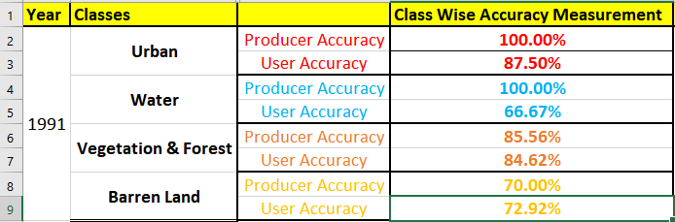

Now following the same procedure like above we get the overall accuracy as well as the producer and user accuracy for the years 2001 and 2011 classified image as below: -

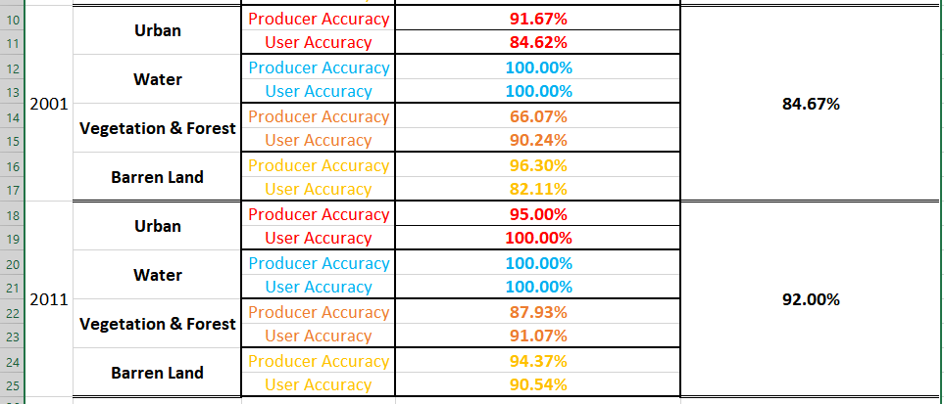

Now the kappa statistics for the classified images for the year 1991, 2001 and 2011 are 0.6328,0.7207,0.8678.

Now from all the above supervised classification of all three images for the years 1991,2001 and 2011 we can see by area, the urbanization has been increased drastically from 1991(10656.8 Hectares) to 2001(27727.2 Hectares) to 2011(41629 Hectares).At the same time, vegetation has been drastically affected negatively mostly from 1991(178382 Hectares) to 2011(125616 Hectares).So we can come up with the outcome that rapid urbanization, which started in early 2000s, has changed the land cover of the area in large margin over the years resulting to more cutting of vegetation and thus rapid uncontrolled urbanization.

Now if we compare the overall accuracy of three images, then we can see overall accuracy of classification has been increased over the decade from 80.67% in 1991 to 92% in 2011. But the overall accuracy does not reveal if error was evenly distributed between classes or if some classes were really bad and some really good, so we have calculated user and producer accuracy too for all different classes of three images.

The user and producer accuracy for any given class typically are not the same. In the above examples for the year 1991, the producer’s accuracy for the Urban class is 100% while the user's accuracy was 87.50%. This means that even though 100% of the reference urban areas have been correctly identified as “urban”, only 87.5% percent of the areas identified as “urban” in the classification were actually urban. Where as for vegetation and forest, even though 85.56% of the reference vegetation and forest areas have been correctly identified as “Vegetation & Forest” area, but 84.6% of the areas identified as “vegetation” in the classification are actually greenery. For Barren land, even though 70% of the reference barren areas have been correctly identified as “barren land” area, but 72% of the areas identified as “barren” in the classification are actually barren land. Same way we can interpret producer and user accuracy for the different classes of the 2001 and 2011 images. In few classes for 2001 and 2011 classified images, we can see user accuracy is better than producer accuracy, which indicates for those classes better classification has been done on 2001 and 2011 images

On the other hand, for the 2011 image, the value of kappa coefficient is 0.8678 which is close to 1. It indicates there is 86.78% better agreement than by chance alone and our classification is significantly better than random for 2011 images when compared to 1991 and 2001 images as their kappa coefficients are lesser than 2011 (0.6328 and 0.7207 respectively for 1991 and 2001).

**Accuracy Assessment: Improving Classification**

Ways to deal with these problems: –

Land use/land cover: incorporate other data

• Elevation, temperature, ownership, distance from streams, etc.

• Context – Spectral inseparability: add spectral data

• Hyperspectral

• Multiple dates –

Atmospheric effects: Atmospheric correction may help –

Scale: Change grain of spectral data

• Different sensor

• Aggregate pixels

Errors in classified map –

Remotely-sensed data should be able to capture classes, but classification strategy does not draw this out.

• Minority classes swamped by larger trends in variability – Use HIERARCHICAL CLASSIFICATION scheme – In Maximum Likelihood classification, use Prior Probabilities to weigh minority classes more.

**Conclusion**

So finally, by analysing the various accuracy and error metrics we can better evaluate the analysis and classification results. Often you might have very high accuracy for certain classes, while others may have poor accuracy. The information is important so you and other users can evaluate how appropriate it is to use the classified map. Choice of reference data is always important as it considers interaction between sensored and desired classification scheme. Error matrix is foundation of accuracy assessment. All forms of accuracy assessment should be reported to user. Interpreting accuracy in classes can yield ideas for improvement of classification.

The End

Thank You